LabAssignment3
Angelina Podolako s1125886
Radboud University

Every student has to hand in **one Word document** that contains:
Result of all 25 C# exercises 2
The URL of the uploaded game Monument and a screenshot of the Monument. 6
Two screenshots of the populated environment using at least 10 objects from a free asset collection of your choice in a reasonable arrangement. 6

Result of all 25 C# exercises
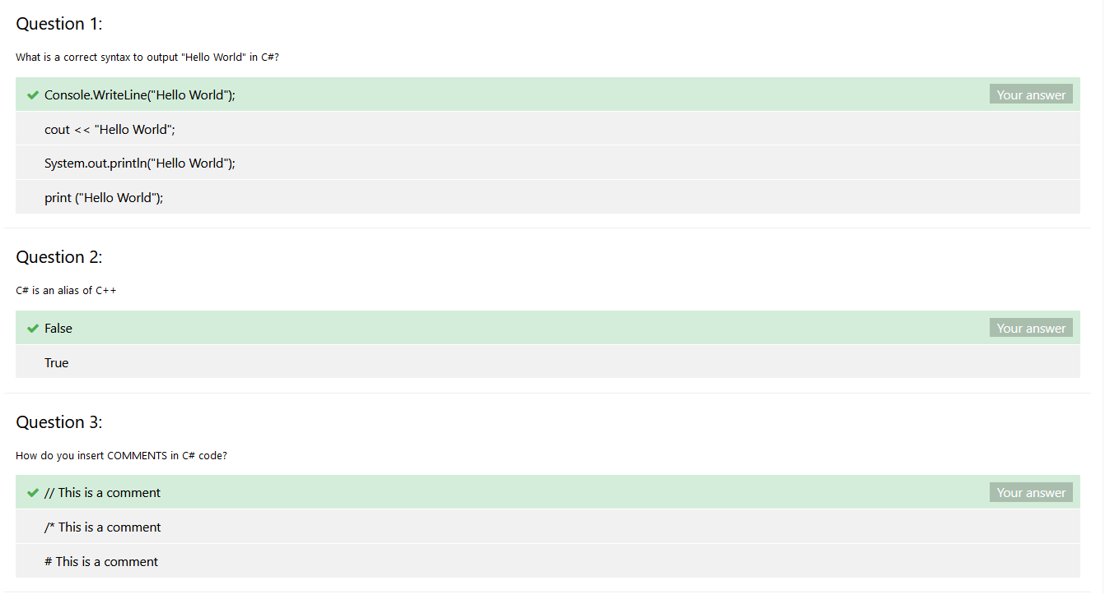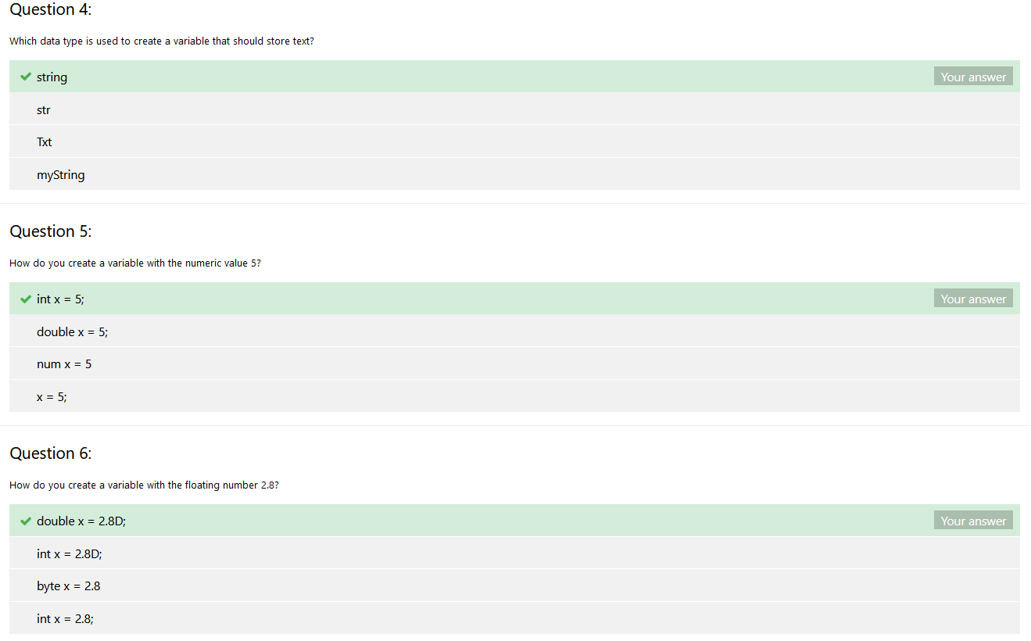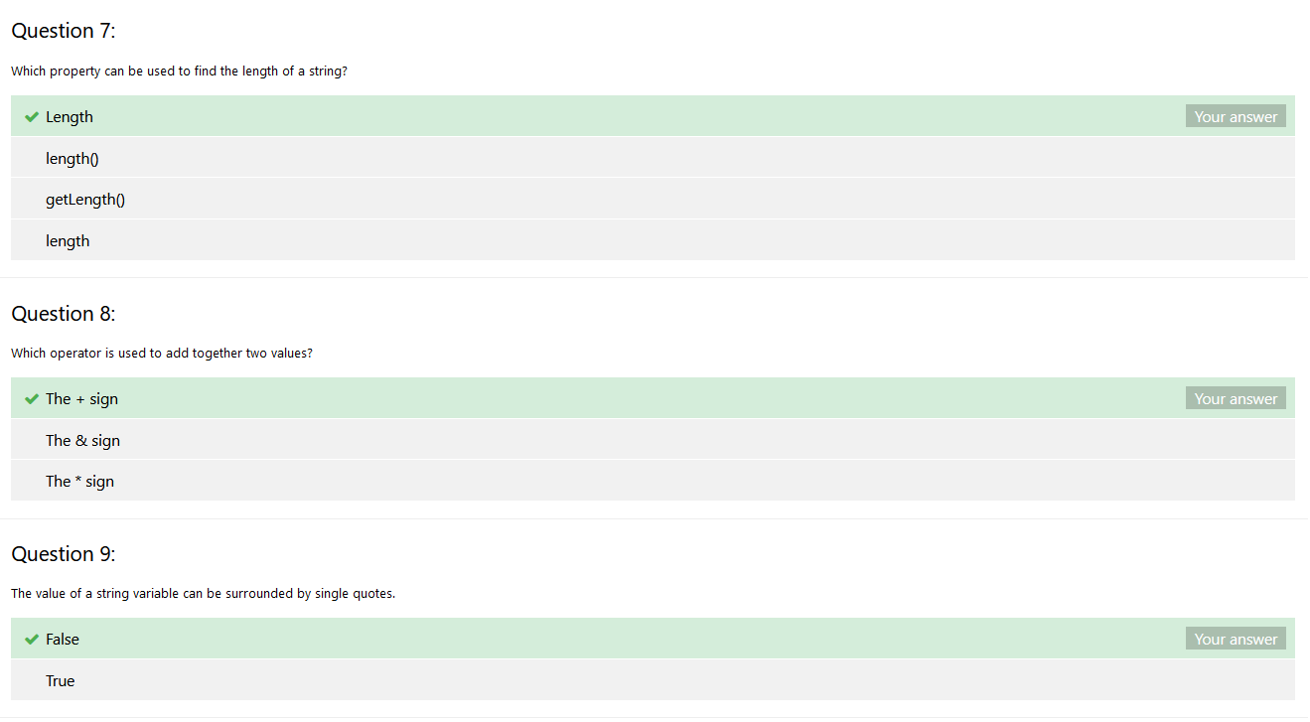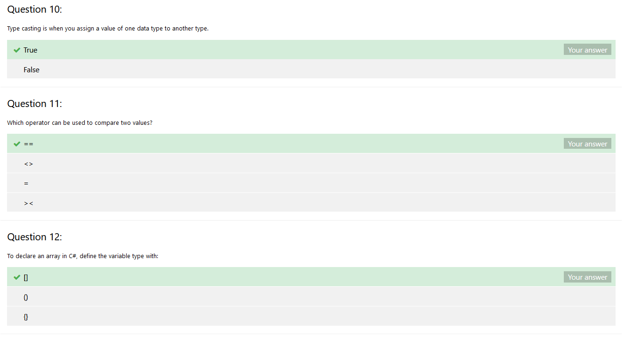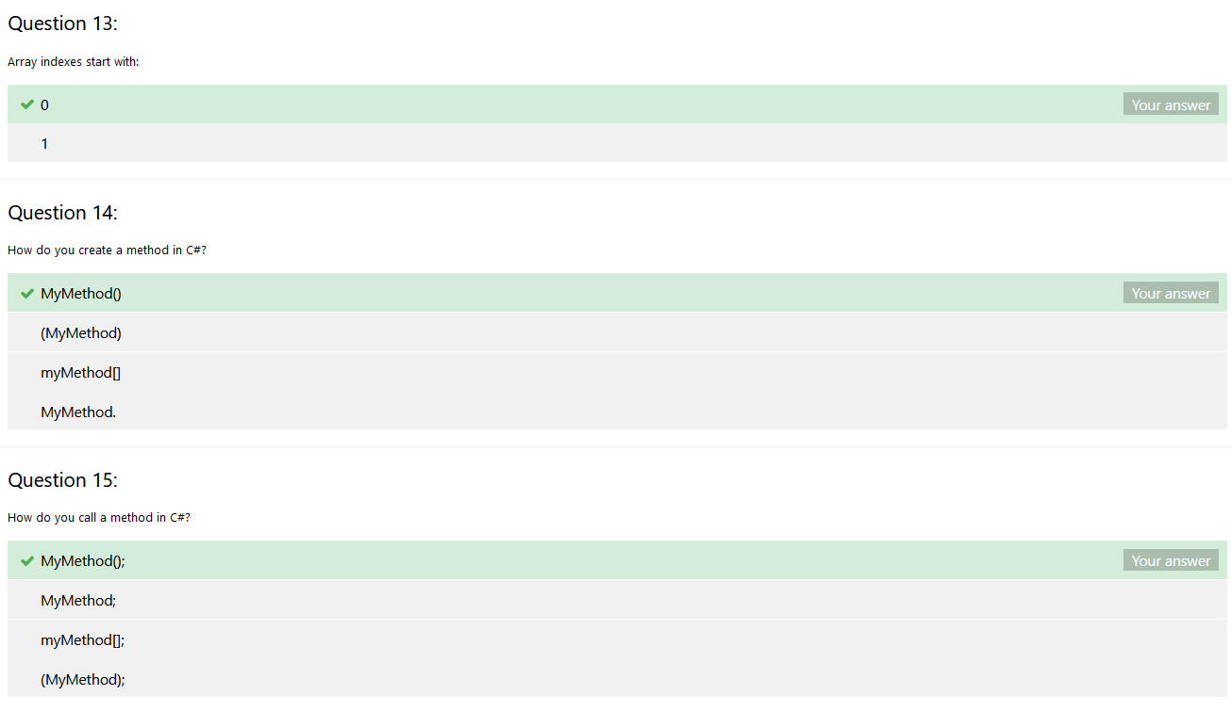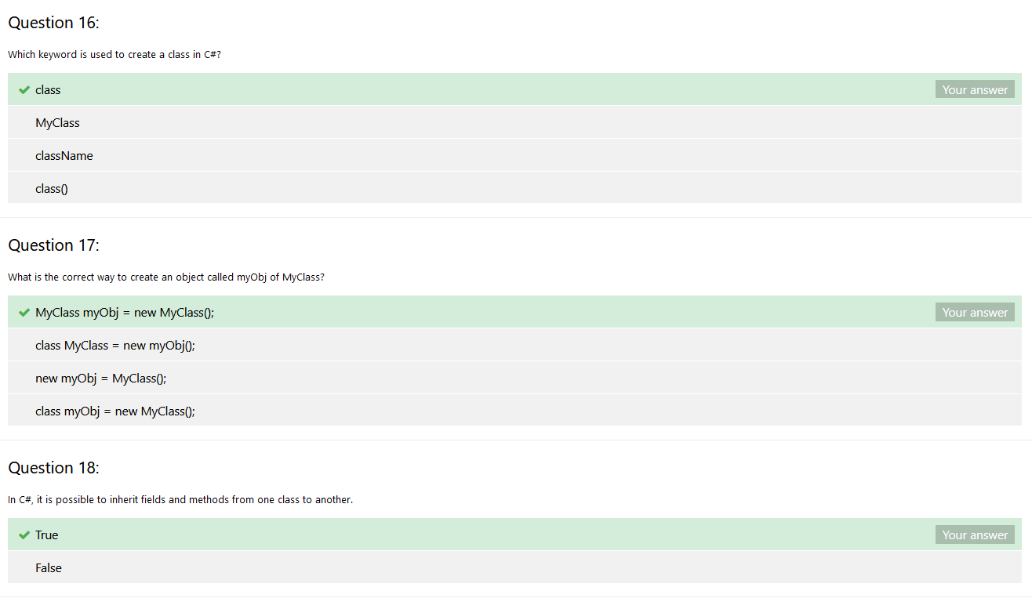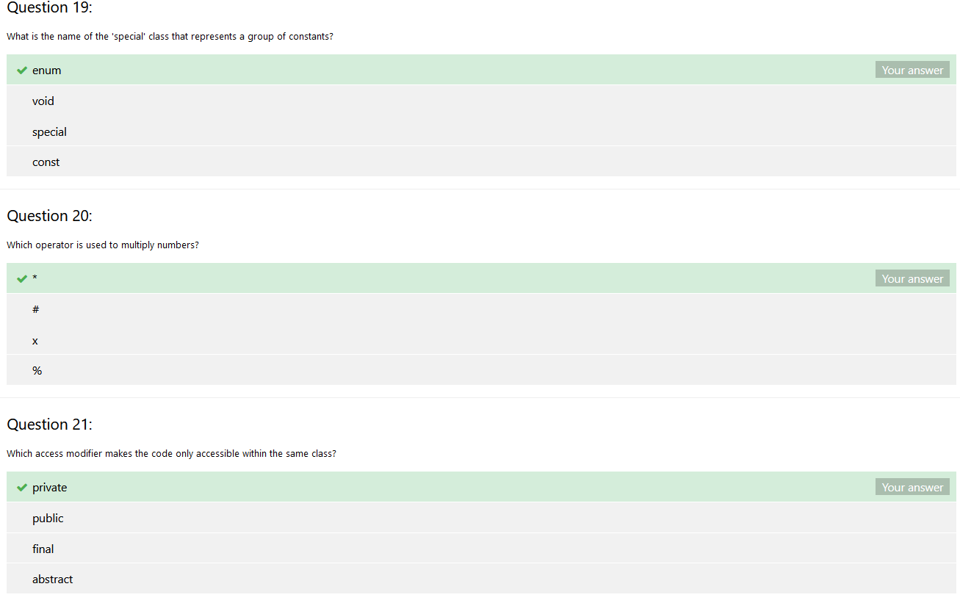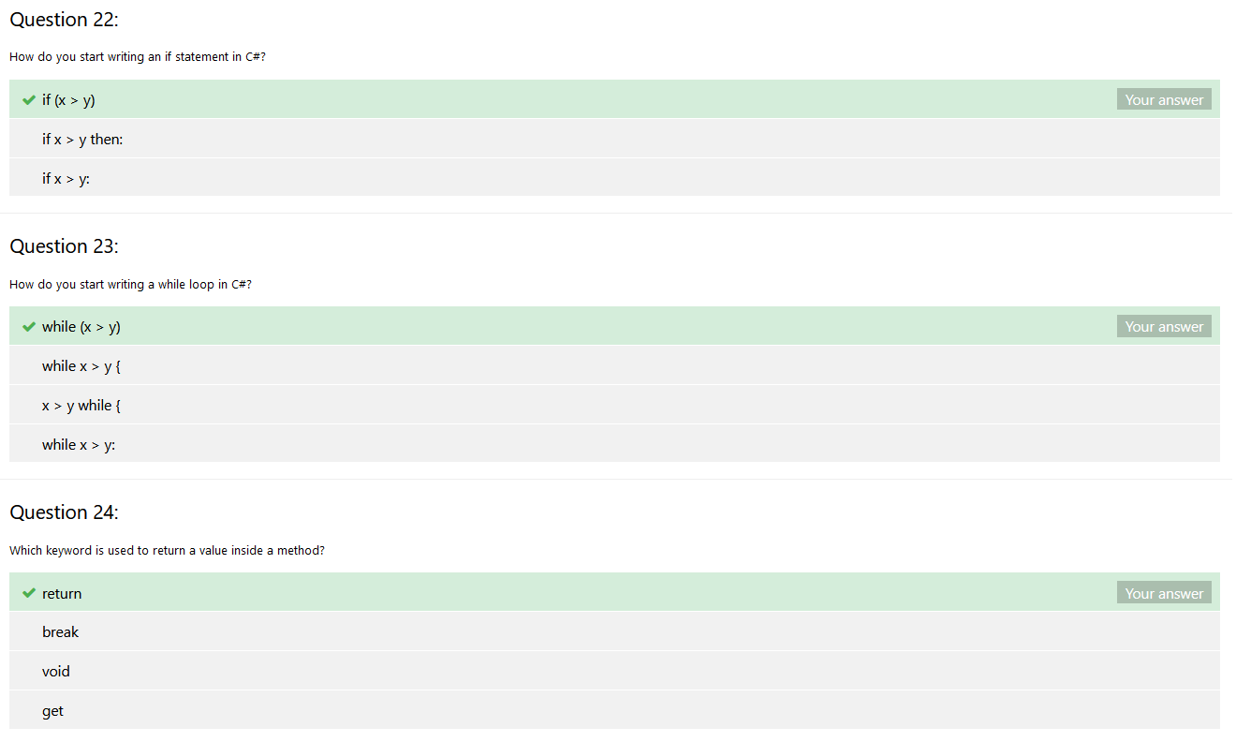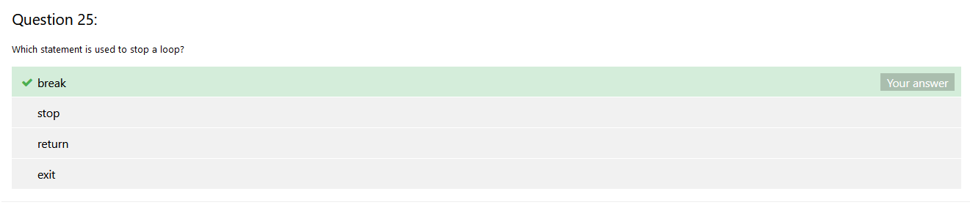

The URL of the uploaded game Monument and a screenshot of the Monument.
https://play.unity.com/mg/other/unity-8bh
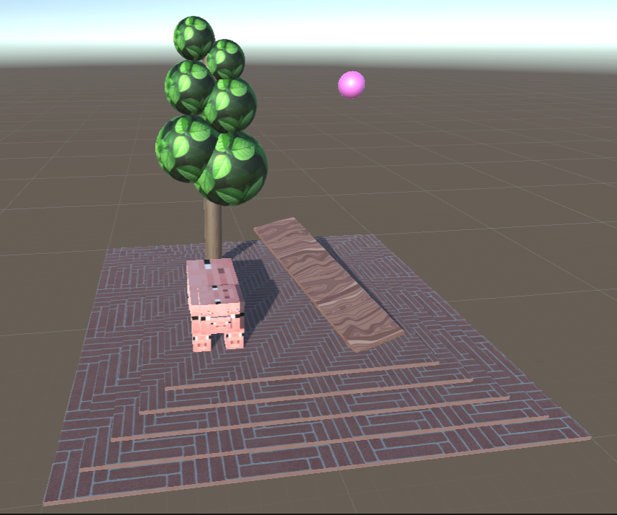

Two screenshots of the populated environment using at least 10 objects from a free asset collection of your choice in a reasonable arrangement.
